**What is a release cycle?**

* To build better products faster, a release cycle is the life cycle of developing, testing, and deploying a product update or a new feature into production.
* It ensures that the new feature or update meets the requirements of the users and is stable enough to be released, while also providing organizations with valuable feedback for improving future versions.
* Careful planning and execution are essential for successful releases – from concept to deployment.
* The release process involved in each stage of a release cycle varies depending on the product or feature.
* Generally, it includes requirements analysis to ensure that the design is suitable for customer needs, development of the feature or product, testing for functionality and performance, and quality assurance before deployment.
* It may also involve planning for subsequent updates and upgrades based on customer feedback.
* When releasing a new feature or product, organizations must consider factors such as cost-effectiveness, compatibility with existing solutions, user experience, scalability, and security.
* The success of any release cycle depends largely on careful research and the effective execution of each stage.

**What are the phases of a release cycle?**

Before any new release, it generally follows a series of steps, beginning with the initial conception and design of the feature or product, followed by development and testing. Once the product has been tested and verified for quality assurance, it can be deployed for use in production environments.

The final step in the release cycle is maintenance, which involves monitoring usage and providing necessary updates as needed. Depending on the nature of the feature, some version releases of the final product may require more frequent updates than others.

The goal of any release cycle is to be agile and ensure customer satisfaction with a high-quality product that meets their needs and expectations.

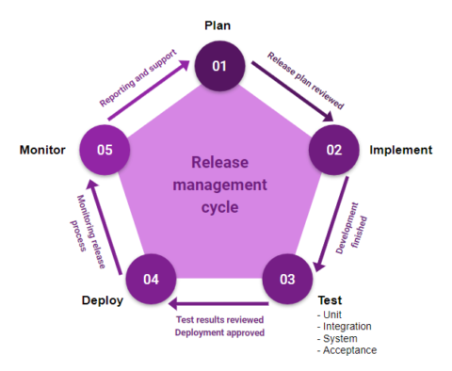

Planning

The first phase of a release cycle is planning. In this phase, the development team creates a roadmap for the release version of a feature or update, including the timeline, resources, and expected outcomes. This phase also involves collecting feedback from stakeholders, such as users and management, to ensure that the feature or update aligns with the business goals.

Development

The development phase involves testing the feature or update before a major release. Developers use various tools, such as version control systems and bug-tracking software, to manage the development process and ensure that all changes are properly documented. This phase may take several weeks or months, depending on the complexity of the feature or update.

Testing

Once the development phase is complete, the feature or update in the release schedule goes through a/b testing to ensure that it meets the requirements and works as expected. This phase focuses on different types of testing, including unit testing, integration testing, canary testing, A/B testing, and more. Testing is a critical part of the release cycle as it helps to identify and fix bugs before the feature or update is released to the end users.

Deployment

The final phase of a production release is deployment. In this phase, the feature or update is released to production. The deployment process may involve various steps, such as deploying the code to servers, configuring the environment, bug fixes, and updating the documentation. Once the automation feature or update is deployed, it is available to the users.

**Benefits of a release cycle**

A release cycle has several benefits for software development teams, including:

**Improved quality:** A release cycle ensures that the feature enhancements are thoroughly tested before release, which reduces the risk of bugs and improves the quality of the software alongside regular security updates.

**Faster time to market**: A release cycle helps to streamline the development process, enabling teams to release features and updates more quickly.

**Better collaboration**: Release notes promote collaboration between developers, testers, and other stakeholders towards achieving milestones for a stable release, which helps to ensure that everyone is working towards the same goals.

**What Is a Sprint Cycle**

* A sprint cycle is a repetitive process that the scrum master and the scrum team must follow throughout the course of a sprint.
* It consists of five elements in total: **sprint planning, daily scrum, sprint review, and sprint retrospective** — with the fifth element being the **sprint** itself, which is made up of the other four elements.

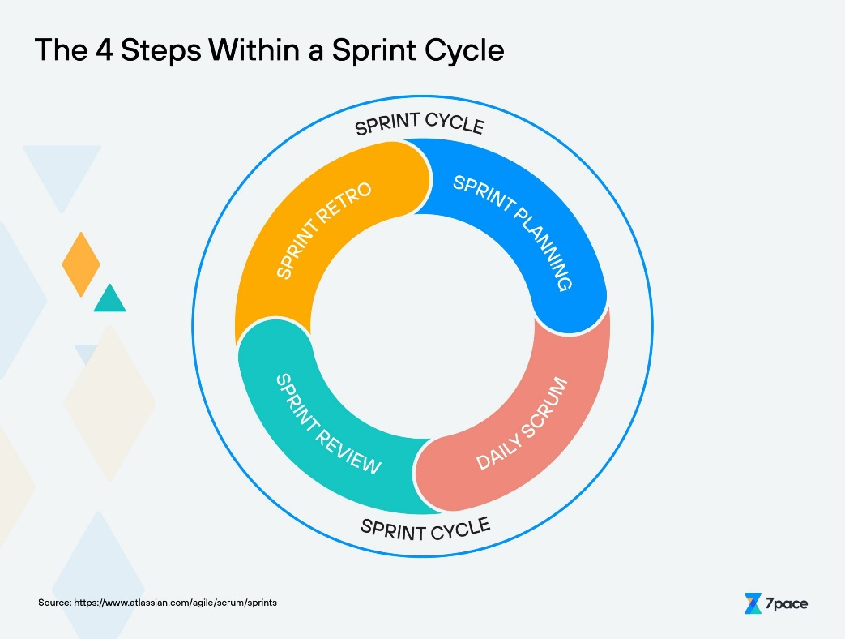

* **Sprint Planning**: The planning session is where the stakeholders and the development team sit together to determine the sprint goal. This is also where they figure out how the work will get done by defining the user stories to focus on during this iteration.
* **Daily Scrum**: The daily standup is a way for project managers or scrum masters to stay in the loop with all the team members’ activities and progress. At the start of every day, the project manager holds a standup session where each team member reports on their work so far and addresses any roadblocks they might have encountered.
* **Sprint Review**: During the review session, the agile team showcases their work throughout the sprint to stakeholders and other team members. This is the chance to address any discrepancies or disagreements before the work hits production.
* **Sprint Retrospective**: At the end of the sprint cycle, the team exchanges ideas about what went right and wrong with the current cycle and suggests ways to improve on the upcoming sprint. It’s an opportunity to learn from your mistakes and further refine the sprint cycle.

**Tips for Developing an Effective Sprint Cycle**

* Keep the entire team on the same page by setting a clear sprint goal and key performance indicators to measure success. Apart from being aware of their individual responsibilities, team members should also know and understand the overarching goal.
* Create a comprehensive sprint backlog that takes all priorities and dependencies into account. If your tasks aren’t in order, that can lead to interruptions and roadblocks for your team down the line.
* Use data to estimate a time frame for each story and sprint, while also keeping in mind potential time-eaters such as team meetings and internal friction. The more data you collect, the better your estimates for time and effort will be.
* Use tools to enable your sprint management process. With the right software, you can easily automate menial tasks in project management, time tracking, data sharing, and online collaboration. Example: Jira, 7pace, Monday.com, Google Workspace, etc.

